COURSE DESCRIPTION FORM
INSTITUTION _National University of Computer & Emerging Sciences

(FAST-NUCES) Karachi_

PROGRAM (S) TO BE BS (Computer Science) / BS (Software Engineering) EVALUATED

A. Course Description

Course Code | CS3002
Course Title | Information Security (Fall 2025)
Credit Hours | 3
Prerequisites by  Course(s) and Topics | CS3001 Computer Networks
Assessment  Instruments with Weights (homework, quizzes, midterms, final, programming  assignments, lab work, etc.) | - Semester Assessments – 20% ( 4 Assignments + 2 Quizzes)  - Assignment #1: 2%  - Assignment #2: 2%  - Quiz 1: 3% (based on Assignment #1)  - Quiz 2: 3% (based on Assignment #1)  - Assignment #3 and 4: 5% each  - Mid-Term 1 Exam – 15%  - Mid-Term 2 Exam – 15%  - Final Exam – 50%
Course Coordinator | Dr. Aqsa Aslam
URL (if any)
Current Course Description | Information security foundations, security design principles; security mechanisms, symmetric and asymmetric cryptography, encryption, hash functions, digital signatures, key management, authentication and access control; software security, vulnerabilities and protections, malware, database security; network security, firewalls, intrusion detection; security policies, policy formation and enforcement, risk assessment, cybercrime, law and ethics in information security, privacy and anonymity of data.
Textbook (or  Laboratory Manual for Laboratory  Courses) | 1– Computer Security, Principles and Practice, William Stallings, 4th Edition, Pearson  Publication, 2018 (Main Textbook for Theory)  2- Computer and Internet Security, A Hands-On Approach, Wenliang Du, 3rd Edition, Create Space Publications, 2022 (for Labs)
Reference Material | - Cryptography and Network Security: Principles and Practice, William Stallings, 8th Edition, Pearson Publication, 2020.  - Principles of Information Security, M. Whitman and H. Mattord, 7th Edition, CENGAGE Learning Inc., 2022

Course Goals | In this course, students learn basics of information security, in both management aspect and technical aspect. Students understand of various types of security incidents and attacks, and learn methods to prevent, detect and react incidents and attacks. Students will also learn basics of application of cryptography which are one of the key technologies to implement security functions. In the last session, teams of students will make presentation of their study project for a topic related to information security.

 |  | CLO |  | Course Learning  Outcome (CLO) | Domain | Taxonomy Level | PLO | Tools
 |  | 01 |  | Explain key concepts of information security such as design principles, cryptography, risk management, and ethics | Cognitive | C2  (Explain) | 1 | A1, A2,  M1, M2, P, F
 |  | 02 |  | Discuss legal, ethical, and professional issues in information security. | Affective | A2 (Discuss) | 6 | A3, A4, P,  M2, F
 |  | 03 |  | Analyze real world scenarios, model them using security measures, and apply various security and risk management tools for achieving information  security and privacy | Cognitive | C4  (Analyzing) | 2 | A3, A4 M2, P, F
 |  | 04 |  | Identify appropriate techniques to tackle and solve problems of real life in the discipline of information security | Cognitive | C4  (Identify) | 3 | A1, A2,  M1, M2, P, F
 |  | 05 |  | Understand issues  related to ethics in the field of information security | Cognitive | C2  (Understanding) | 8 | A4, P, F
 |  | Tool: A = Assignment, P = Project, M = Mid-term (M1 and M2), F=Final (End-term)
 |  |  | B. Program Learning Outcomes
 |  |  | For each attribute below, indicate whether this attribute is covered in this course or not. Leave the cell blank if the enablement is little or non-existent.
 |  | 1.Computing Apply knowledge of mathematics, natural sciences, Knowledge: computing fundamentals, and a computing specialization to the solution of complex computing problems. |  |  |  |  |  |  |     
 |  | 2.Problem Identify, formulate, research literature, and analyse  Analysis: complex computing problems, reaching substantiated conclusions using first principles of mathematics, natural sciences, and computing sciences. |  |  |  |  |  |  |     
 |  | 3.Design/Develop Design solutions for complex computing problems and  Solutions: design systems, components, and processes that meet specified needs with appropriate consideration for  public health and safety, cultural, societal, and environmental considerations. |  |  |  |  |  |  | 
4.Investigation & Conduct investigation of complex computing problems
Experimentation: using research-based knowledge and research-based methods.

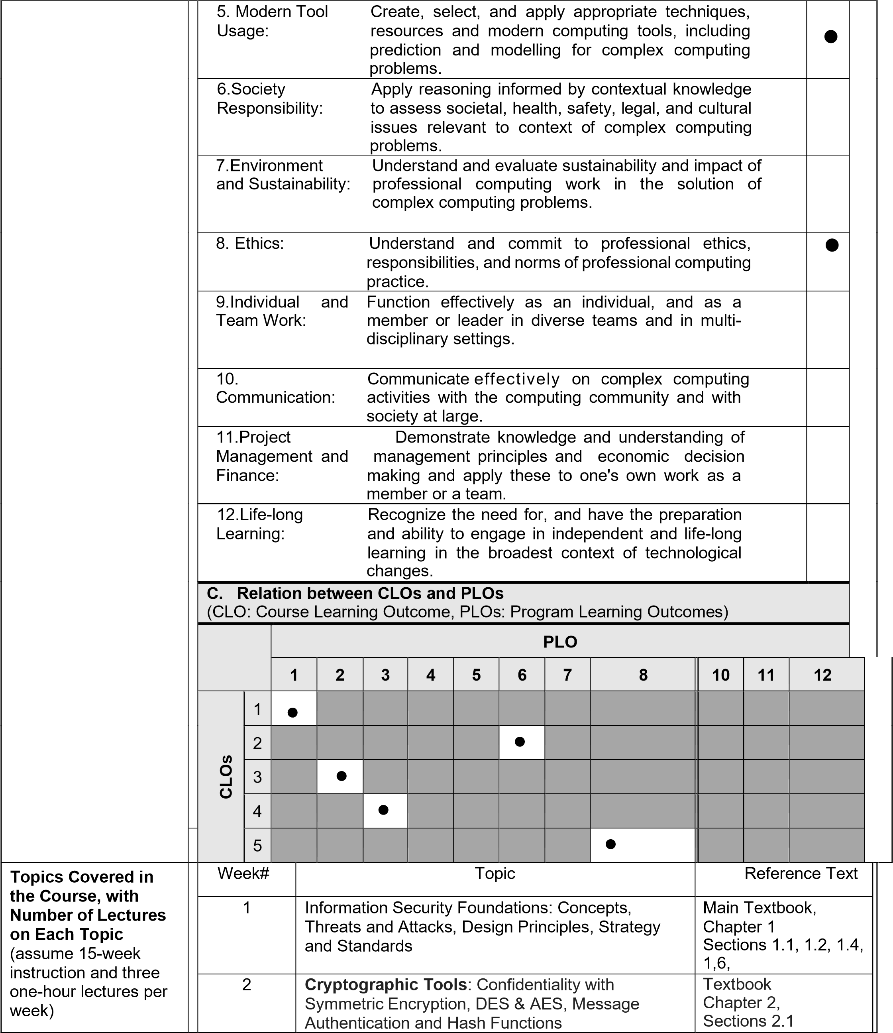

 |  | 3 | Cryptographic Tools: Public Key Encryption,  RSA  Assignment# 1 | Textbook Chapter 2,  Section 2.3  Details in Chapter 21
 |  | 4 | Cryptographic Tools: Digital Signatures and Key Management | Textbook Chapter 2, Section 2.4
 |  | 5 | User Authentication: Digital User  Authentication Principles, Password based authentication  Quiz# I from assignment#1 | Textbook Chapter 3, Sections 3.1 to 3.2
 |  | MIDTERM-I EXAM
 |  | 6 | User Authentication: Token-based, and Biometric authentication and related security issues | Textbook Chapter 3, Sections 3.3 to 3.6
 |  | 7 | Access Control: Principles, Discretionary  Access Control, Role-based Access Control and  Attribute based Access Control | Textbook Chapter 4, Sections 4.1 to 4.7
 |  | 8 | Database Security: Need, SQL Injection  Attacks, Database Access Control and  Database Encryption  Assignment# 2 | Textbook Chapter 5, Sections 5.1 to 5.7
 |  | 9 | Malicious Software: Types, Propagation,  Payload, and Countermeasures | Textbook Chapter 6, Sections 6.1 to 6.10
 |  | MIDTERM-II EXAM
 |  | 10 | Intrusion Detection: Basics, Types and  Examples  Quiz# II from assignment 2 | Textbook Chapter 8, Sections 8.1 to 8.6
 |  | 11 | Firewalls and Intrusion Prevention:  Basics, Types, and Prevention Systems  Assignment# 3 | Textbook Chapter 9,  Sections 9.1 to 9.3 and 9.6
 |  | 12 | Software Security: Software Vulnerabilities and Protection Mechanisms | Textbook Chapter 11, Sections 11.1 to 11.3
 |  | 13 | IT Security Management and Risk  Assessment: security policies, policy formation and enforcement, risk assessment | Textbook Chapter 14, Sections 14.1 to 14.3
 |  | 14 | Legal and Ethical Aspects:  Cybercrime, Intellectual Property, Privacy and Anonymity of Data and Ethical Issues. Assignment# 4 | Textbook Chapter 19, Sections 19.1 to 19.4
 |  | 15 | Revision, Queries, and Any Remaining Matters
 |  | 16 | Final EXAM

Laboratory  Projects/Experiments  Done in the Course | Students will be given assignments related to the theory concepts they learn in classroom lectures. A project (research / development) discussing issues related to the state-of-theart information security concepts will also be assigned.
Programming Assignments Done in the Course | A few programming labs are given to apply the key concepts of information security.
Class Time Spent on (in % credit hours) | Theory |  | Problem Analysis | Solution Design | Social and Ethical Issues
 | 40% |  | 25% | 25% | 10%
Oral and Written Communications | Every student group is required to submit at least 01 written report of typically 06 to 08 pages (IEEE Format) and to make 01 oral presentations of typically 15 minute’s durations. Include only material that is graded for grammar, spelling, style, and so forth, as well as for technical content, completeness, and accuracy.
Late Submission &  Plagiarism Policy  Policy | Deadlines are meant to be strictly followed. Any late submission (without and valid reason and justification/ evidence) will be penalized. The penalty will be 50%. Any delay of more than a week would mean ZERO credit in that particular assessment  (assignments, labs, project). Plagiarized assignment will get you ZERO credit.
Instructor Name Hira Tunio
Instructor Signature

Date: August 15, 2024

